**PCB Artist Introduction**

**1st Laboratory Report for ECE 383**

**Microcomputers**

**Submitted by**

**Shomari Thomas**

**11672867**

**The University of Alabama**

**Tuscaloosa, Alabama 35487**

**January 22, 2020**

**Abstract**

This lab was designed to introduce us to the program PCB Artist. PCB is an acronym that stands for Printed Circuit Board. In the lab, we learned how to design electronic circuits using PCB Artist’s schematic tool and then generate a layout of the design using the PCB tool. The first task was to create a circuit in PCB Artist from a tutorial given in the program. This task also included writing definitions. The second task was to create a timer circuit in the PCB Artist program. The third task required taking the contents of the second task and converting it to a Printed Circuit Board Layout in the program. The fourth and final task involved creating a Schematic Symbol, a PCB Footprint, and a Component in the PCB Artist program.

**Introduction**

The objective of this lab is to become more familiar with the PCB Artist program. Task one has us creating the tutorial circuit, drawing a basic printed circuit board, and defining some important terms. Task two has us creating a basic timer circuit using a 555 timer chip in the design. Task three has us taking the design of task two and converting it into a printed circuit board format. Task four, the final task, has us creating a PCB Artist component for the PIC24HJ128GP502 microcontroller.

**Procedure/Results**

Task one had us create a circuit in PCB Artist based on the tutorial, as well as some other definitions.

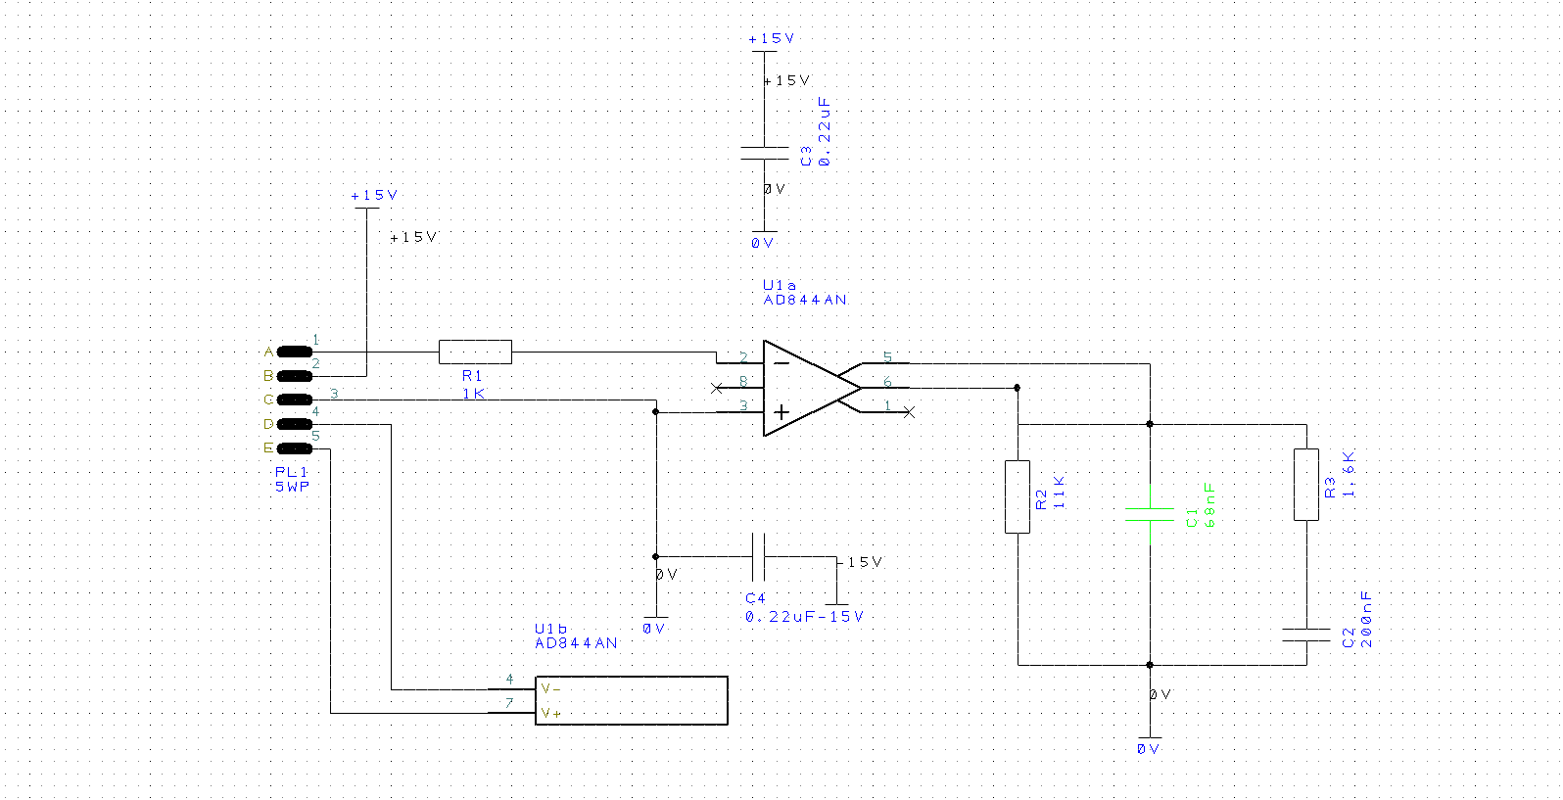

Silkscreen

Soldermask

Copper

Substrate

1. Usually, a PCB is made of four known layers of different materials. Describe the four layers in your own words.

SilkScreen – the top layer, above the solder mask, adds different indicators for the PCB, shows

what each of the nodes and soldering should do for a better understanding of what the parts on

the board represent.

Solder Mask – Above the copper foil, makes the PCB appear green, insulates the copper.

Copper – Can be on one or two sides and is a thin layer of copper applied to the substrate.

Substrate (FR4) – A solid core for a PCB, usually fiberglass, and makes up the majority of the

thickness of the PCB

2. Define the following terms in your own words:

a) Finger – Metal pads that make the connection between two circuit boards.

b) Pad – A place on a PCB that has bare metal where a component is soldered to the board.

c) Panel – A larger PCB that will be later split into multiple smaller PCBs.

d) Plated through hole – Any hole on the board which has 1) an annular ring and 2) is plated

through the board

e) Silkscreen – the top layer of a PCB which contains information about the board, printed

directly onto the board.

f) Soldermask - a covering, insulating layer above the copper foil, which gives the PCB its color.

g) Surface mount – A method of developing PCBs that does not require leads passing through

holes in a board.

h) Via – A hole in a PCB that allows a signal to pass through to the other side of the board.

Task two included creating a circuit in PCB Artist that represents a timer using a 555 timer chip.

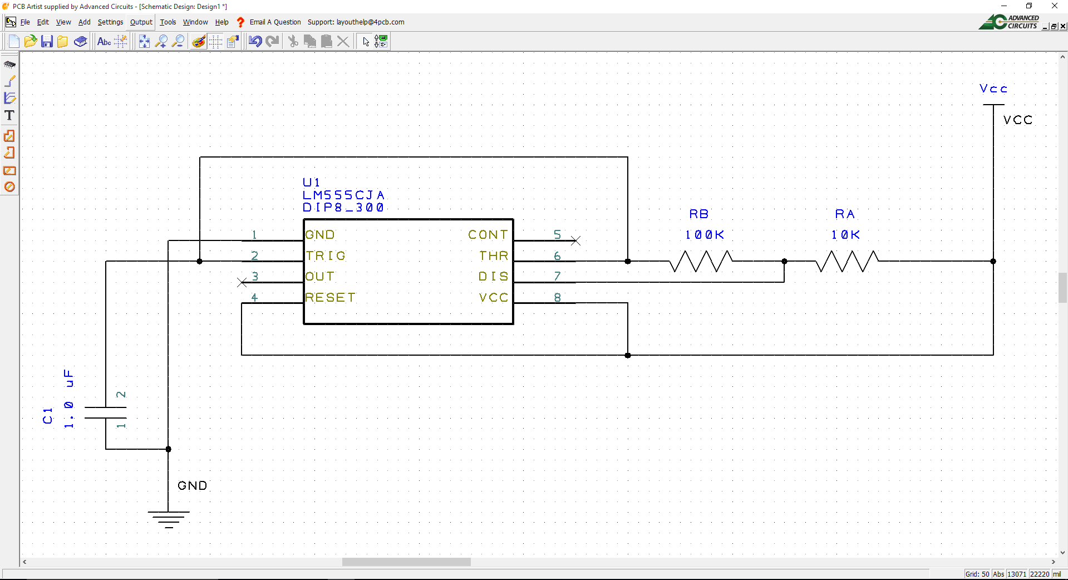

Task three had us take the design of task 2, and converts it into a Printed Circuit Board Layout design.

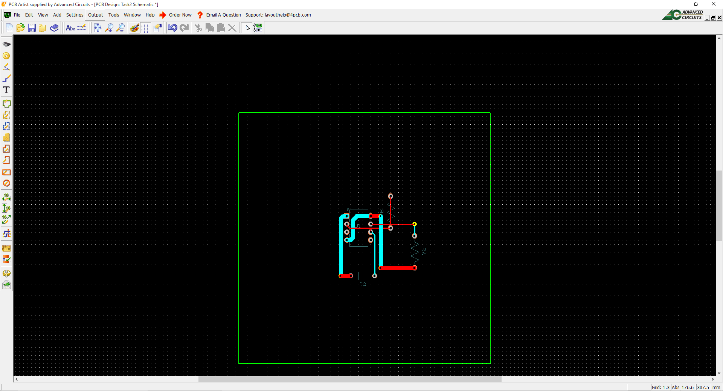

Task Four included creating a component for the PIC24HJ128GP502 Microcontroller. By following several steps, a component was successfully created.

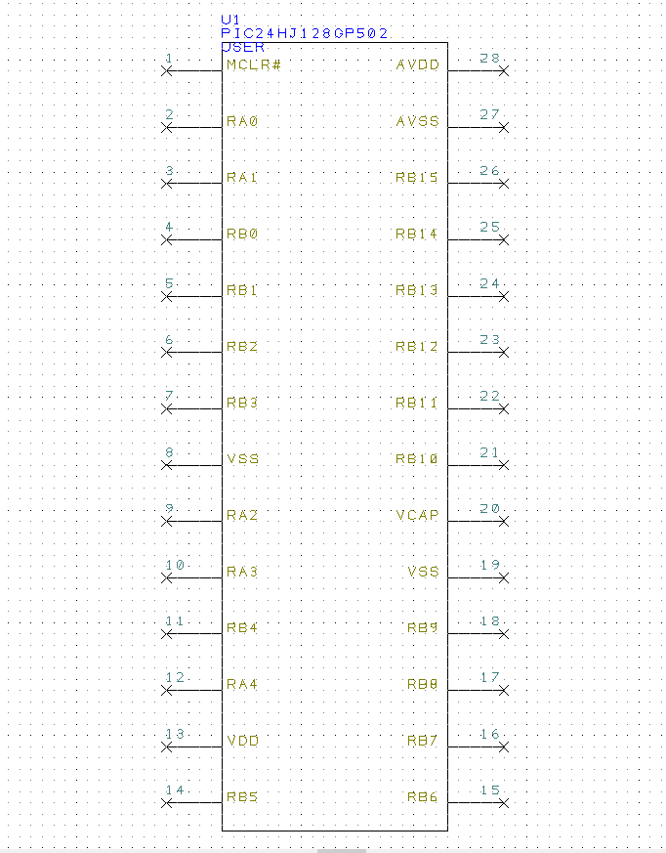

**Conclusion**

This first lab was a learning experience for the PCB Artist program. We were taught how to create basic circuits and components in PCB Artist. We now know how to properly create symbols, printed circuit board layouts, and how to access many of the libraries available in the PCB Artist program. Overall, we now have a better understanding of printed circuit boards and the PCB Artist program.